**ASSIGNMENT-3.5**

1. Using Java API copy a file from HDFS to Local file system

* ***Create a file in Local file system and copy the file to HDFS by put command***

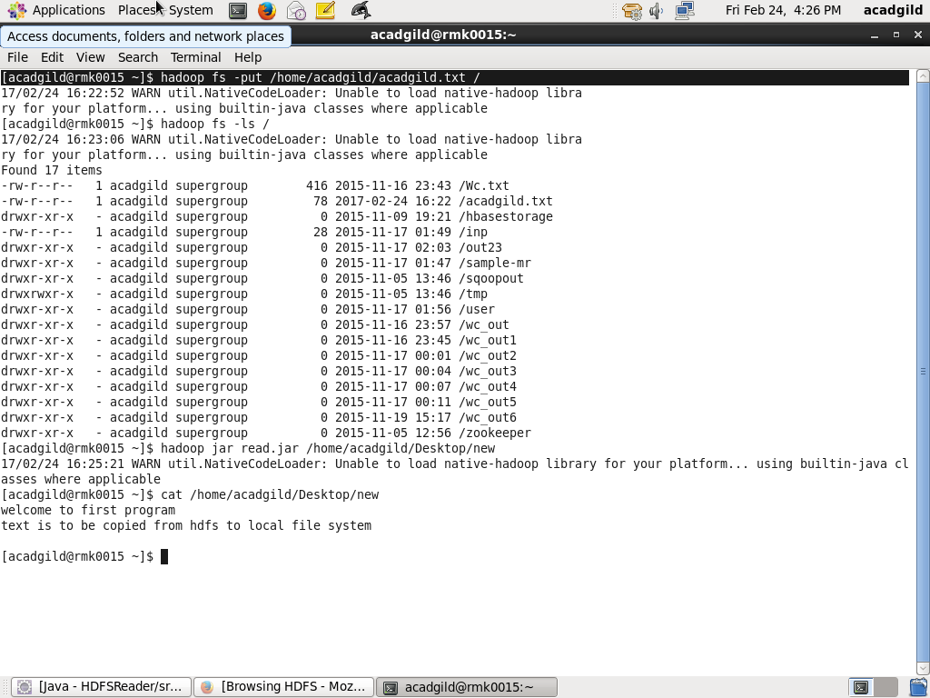

* ***Checking the existence of copied file***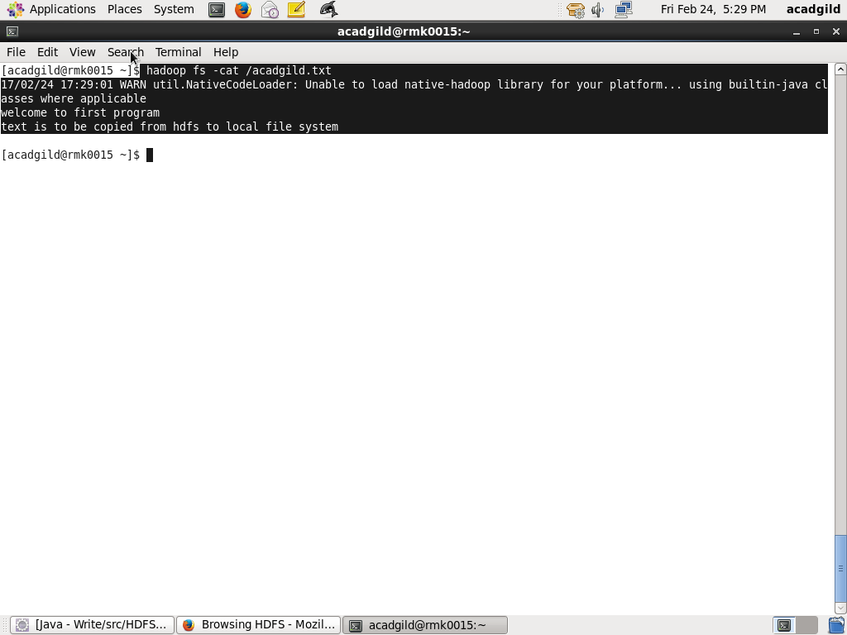
* ***Copy the file from HDFS to Local File System by exporting the program as a jar file***

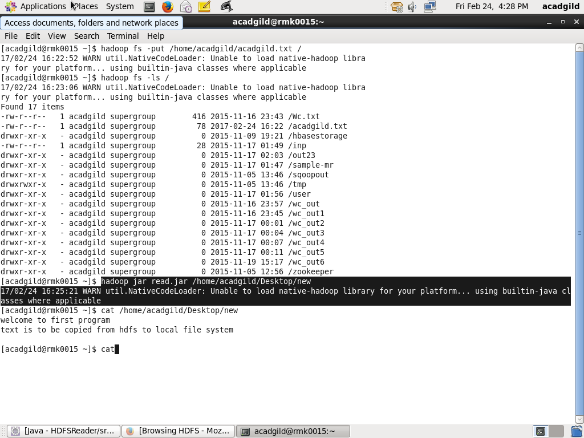

***Y***

* ***Display the copied file contents by using cat command***

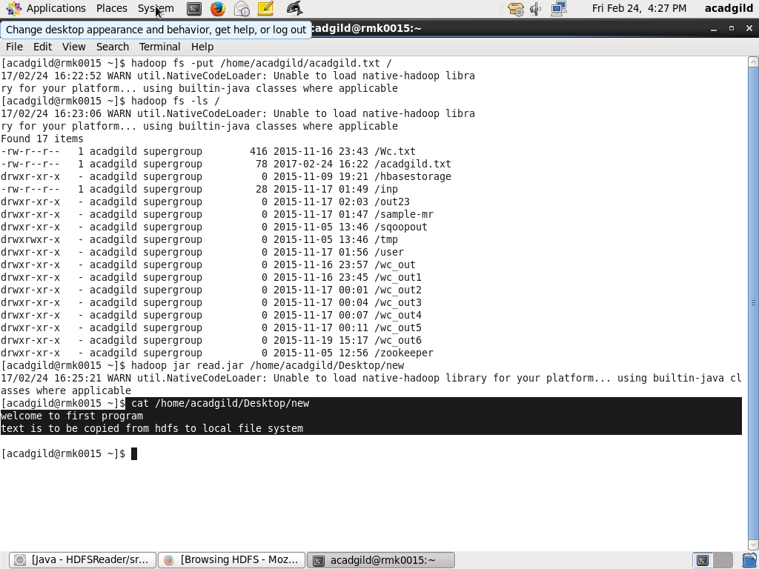

1. Using Java API copy a file from LFS to HDFS

* 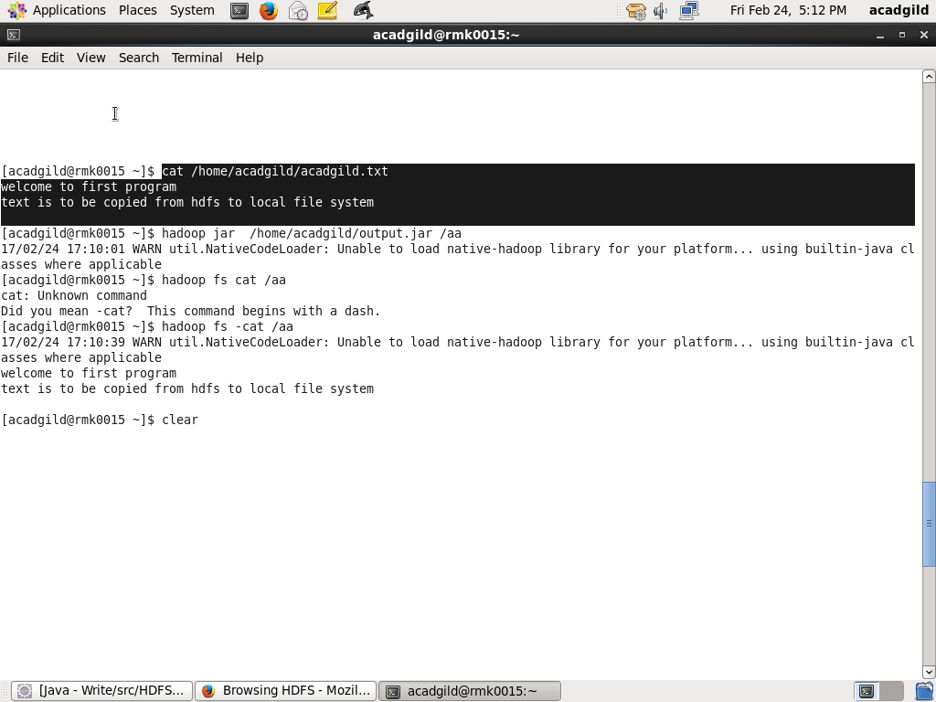***Check whether a file is present in HDFS and display the content***
* ***Copy the file from Local File System to HDFS by exporting the program as a jar file***

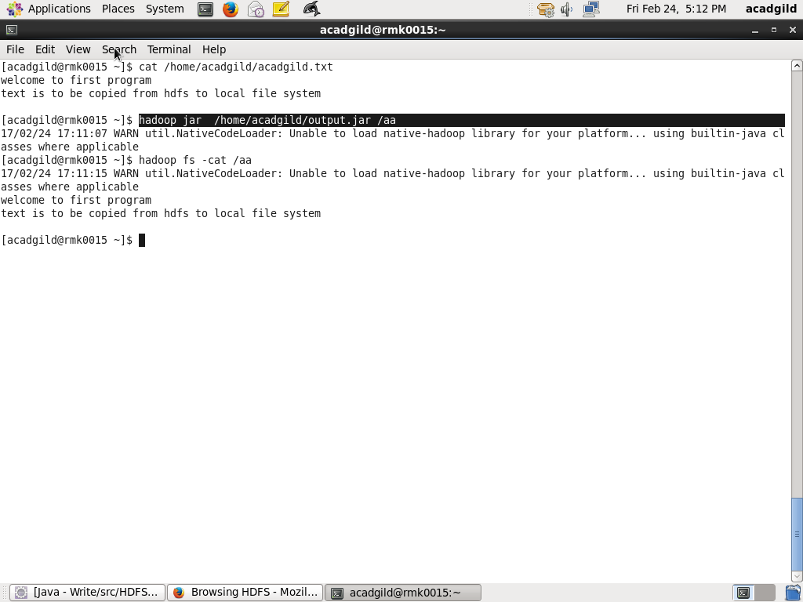

* ***Display the copied text***

